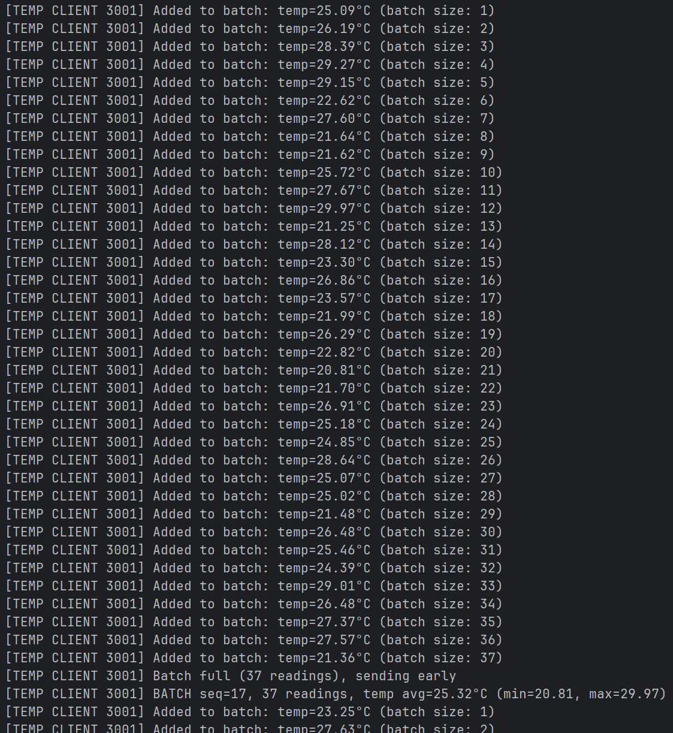
When we are running the batching test with a very low interval as shown above, a lot of readings is collected which exceeds the payload limit as shown above
Our code forces the packet to be sent early to avoid exceeding the payload limit as shown above

